Project: Moffat Bay Lodge | Team Charlie : James Brown III, Gabriel Conner, Paul Fralix, Alexis Mitchell, Hlee Xiong
Course: CSD460 Capstone in Software Development
Description: Functional test plan for validating the Contact Inquiry form and backend PHP validation logic in about_us.php, including required field checks, email format validation, and success/error message handling.

Date: 2026/05/03
.
TABLE OF CONTENTS
Successful Inquiry Submission 2-3
Missing Required Fields 4-5

Test 1 | Successful Inquiry Submission
 | Test Objective: Verify backend accepts valid input and returns success message | Developer: Hlee Xiong  Date tested: | Peer tester: Paul Fralix  Date tested: 2026/05/03
Step | Action | Expected results: | Developer pass/fail | Tester pass/fail  + Screenshot
1 | Navigate to about_us.php | Page loads with form fields visible | Yes | 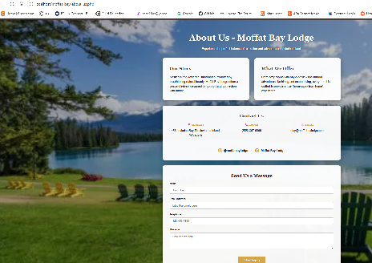  Pass
2 | Enter valid name (e.g., “John Smith”) | Name field accepts input | Yes | 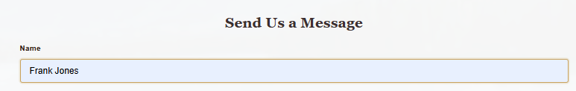  Pass
3 | Enter valid email (e.g., “john@example.com”) | Email passes | Yes | 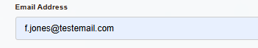  Pass
4 | Enter valid message (20+ characters) | Message accepted | Yes | 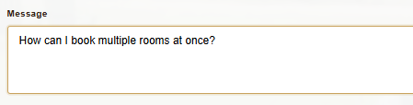  Pass
5 | Click Submit Inquiry | Page reloads and displays green success alert: “Thank you, John Smith! Your inquiry has been sent.” | Yes | Pass
Comments | This test confirms that the backend validation logic correctly identifies valid input and triggers the success message block. The form fields should reset to empty after submission, as coded in the PHP file. Peer tester verified that no error message appears and that the success alert is styled correctly.

Test 2 | Contact Us Form: Missing Required Fields
 | Test Objective: Ensure backend prevents submission when required fields are empty | Developer: Hlee Xiong  Date tested: | Peer tester: Paul Fralix  Date tested: 2026/05/03
Step | Action | Expected results: | Developer pass/fail | Tester pass/fail
1 | Navigate to about_us.php | Page loads normally | Yes | Pass  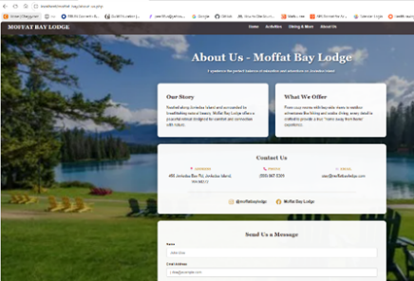
2 | Leave name blank | Name field empty | Yes | 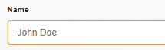  Pass
3 | Enter a valid email and message | Email and message accepted | Yes | 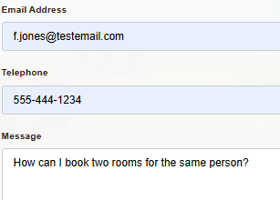  Pass
4 | Click Submit Inquiry | Red error alert appears: “Please fill out all required fields.” | Yes | Pass
5 | Attempt to resubmit without correcting fields | Error persists; no success message | Yes | 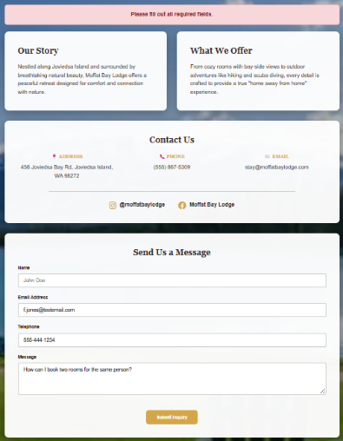  Pass
Comments | This test verified that the backend correctly checks for empty required fields (name, email, message). The error message should appear in the red alert box defined by .error-message. Peer tester confirmed that the form does not clear input fields and no success message was shown.

